http://www.justice.gov.za/vg/nrso.html

home about us resources newsroom courts tenders jobs contacts


Criminal Law
Home> Criminal Law> NRSO

FAQ: National Register for Sex Offenders (NRSO)
Clearance Certificates
The issuing of clearance certificates or verifying individuals for any purpose is not yet operational.
People applying for employment, entity registration or clearance certificates, are advised that, in addition to the acquisition of the SAPS clearance certificate, to also disclose to their employers (on affidavit) that they have never been convicted of a sexual offence against a child or a mentally disabled person. This is provided for in terms of Section 46(1), (2) and (3) of the Criminal Law (Sexual Offences and Related Matters) Amendment Act, 32 of 2007. This affidavit, must be placed in the employee's file to be utilised at a future date once the Register becomes fully operational.
Applying for a Police Clearance Certificate
ALSO NOTE: Criminal Law (Sexual Offences and Related Matters) Amendment Act (32/2007): Order issued by the North Gauteng High Court, Pretoria in relation to section 48, GG 32850, Nr 1670, 29 Dec 2009

NRSO Forms l Factsheets
The cornerstone of the Criminal Law (Sexual Offences and Related Matters) Amendment Act, No. 32 of 2007 (SORMAA), is the National Register for Sex Offenders (NRSO). As part of curbing the prevalence of sexual offences in South Africa, the Department of Justice and Constitutional Development has, in terms of Chapter 6 of the Act, implemented the National Register for Sex Offenders on 30th June 2009.
National Register for Sex Offenders (NRSO) aims to stop the spate of incidents against children and mentally disabled people:
- The NRSO was established by an Act of Parliament in 2007.
- It is a record of names of those found guilty of sexual offences against children and mentally disabled people.
- The register gives employers in the public or private sectors such as schools; crèches and hospitals the right to check that the person being hired is fit to work with children or mentally disabled people.
- Being found guilty of a sexual offence against a child or mentally disabled person will result in one’s name being put on the National Register.
- The Register seeks to ensure that offenders do not work with children or mentally disabled people.
- Convicted offenders are also not allowed to apply for foster care or adoption, or to work with children.
- Employers can find out whether the people they put in charge of their children have not been found guilty of sexual offences in terms of the law.
INQUIRY BY EMPLOYER TO THE NATIONAL CHILD PROTECTION REGISTER AND THE NATIONAL SEX OFFENDERS REGISTER
The National Child Protection Register - In terms of section 126 of the Children’s Act, 2005 (Act 38 of 2005) employers offering services which allow for access to children must, before employing a person, establish from the Registrar of the National Child Protection Register whether or not the potential employee’s name is on Part B of the National Child Protection Register. If the potential employee’s name appears on the Register, he or she will not be allowed to work in an environment which allows for access to children, since persons whose names appear on the Register have been found unsuitable to work with children by the court.
In order to establish whether the person’s name appears in Part B of the Child Protection Register, the employer should complete a Form 29, which they can obtain from the Department of Social Development, and send it to CPRenquiries@dsd.gov.za. The contact number for the Registrar is 012 312 7554.
The National Sex Offenders Register - The Criminal Law (Sexual Offences and Related Matters) Amendment Act, 2007 (Act 32 of 2007) have similar provisions providing for the National Sex Offenders Register which records the names of persons who have been convicted of charges of sexual offences committed against a child or a mentally disabled person. These persons are similarly not permitted to work with or have access to children or mentally disabled persons.
The employer should complete a Form 8 (Annexure B of the Regulations), which they can obtain from the Department of Justice and Constitutional Development. Ms Ntombizodwa Matjila is the Registrar of the National Sex Offenders Register and her contact details are as follows: email: NMatjila@justice.gov.za and telephone number 012 315 1656.

Q1. Is there a sex offender register, administered by the Department of Justice and Constitutional Development, in place as prescribed by the Sexual Offences Act?
Yes, there is a register used to record the details of all offenders who have been convicted of a sexual offence against children and mentally disabled persons. This is the database which is administered by the Department of Justice and Constitutional Development. This database is only accessible directly by the National Registrar for Sex Offenders and indirectly by the South African Police Service, the Department of Correctional Services, the Department of Health and the Department of Social Development.
Q2. What is the National Register for Sex Offenders?
The National Register for Sex Offenders is a database containing particulars of persons:
- convicted of any sexual offence against a child or a person who is mentally disabled;
- alleged to have convicted alleged to have committed a sexual offence against a child or a person who is mentally disabled in respect of whom a court, has made a finding and given a direction that the offender is mentally unfit to stand trial.
Q3. What is the purpose of the National Register for Sex Offenders?
It is to protect children and persons who are mentally disabled against sexual offenders by establishing and maintaining a record of persons who –
- have been convicted of a sexual offence against a child or a person who is mentally disabled whether committed in or outside the Republic or
- alleged to have committed a sexual offence against a child or a person who is mentally disabled in respect of whom a court has made a finding and given a direction that the offender is mentally unfit to stand trial.
Q4. Who is responsible for the management of the National Register for Sex Offenders?
- The Minister of the Department of Justice and Constitutional Development establishes and maintains the Register.
- The National Registrar for Sex Offenders administers the National Register for Sex Offenders.
- Police, Department of Correctional Services, the Department of Health and the courts nationwide submit the relevant information for the registration of offenders.
Q5. What type of information must be contained in the National Register for Sex Offenders?
- Personal details: offender’s title, full names and surname, including any known alias or nickname where applicable, the profession or trade;
- Contact details: the last known physical address, any contact details, including a postal address where applicable;
- the identity number, passport number and driver’s licence number where applicable;
- the type of sexual offence for which the offender has been convicted and whether or not it was committed against a child or a person who is mentally disabled, the sentence, as well as the relevant prisoner identification number where applicable;
- the court in which the trial took place and the case number;
the name of the medical institution or medical practitioner of a person and details of the sexual offence allegedly committed by a person who has been alleged to have committed a sexual offence against a child or a person who is mentally disabled in respect of whom a court, has made a finding and given a direction that the offender is mentally unfit to stand trial.
- any other particulars as may be prescribed by regulation; and
- if the conviction and sentence took place in a foreign jurisdiction, contain as far as possible the equivalent information as obtained from the relevant country or any other legal source.
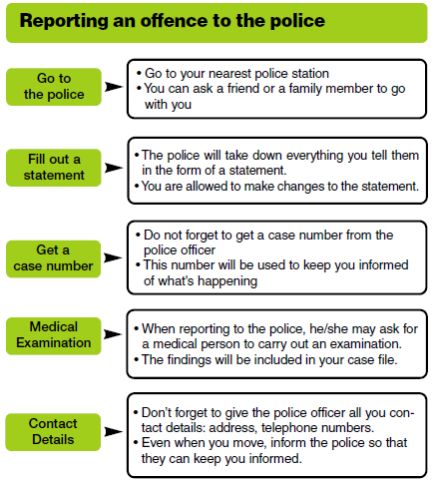Q6. Is the registration of an offender in the register a violation of the Bill of Rights?
No, the National Register for Sex Offenders complies with the Bill of Rights and the information contained in the register is treated with utmost confidentiality.
What Sexual Offences may be committed against children and persons who are mentally disabled?
- Rape
- Compelled rape
- Sexual assault
- Compelled sexual assault;
- Compelled self-sexual assault
- Acts of consensual sexual penetration with certain children (statutory rape)
- Acts of consensual sexual violation with certain children (statutory sexual assault)
- Compelling or causing children to witness sexual offences, sexual acts or self masturbation
- Exposure or display or causing of exposure or display of genital organs, anus or female breasts to children
- Sexual exploitation of children and persons who are mentally disabled;
- Sexual grooming of children and persons who are mentally disabled;
- Exposure or display of or causing exposure or display of child pornography or pornography to children or persons who are mentally disabled;
- Using children or persons who are mentally disabled for pornographic purposes or benefiting there from.
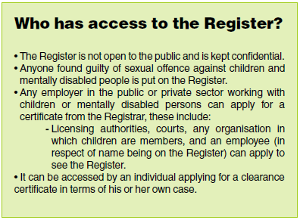Q7. Is the National Register for Sex Offenders accessible to the public?
- The contents of the National Register will not be made available to the public. Only those entitled to apply for a clearance certificate will have access to the information contained in the National Register. It is a criminal offence for anyone to disclose or publish information contained in the National Register.
Q8. May members of the public enquire about the details of entries (e.g. type of offence, date committed, sentences, etc.) or the movements of the sex offenders?
- Yes, only if those members of the public fall in the category of Employers, a Relevant Authority (department of state or administration in the national, provincial or local sphere of government; other functionary or institution exercising a power or performing a duty in terms of the Constitution of the Republic of South Africa, 1996),
- an employee in respect of her own particulars,
- a person applying for a license or approval to manage or operate any entity,
- a person applying to become a foster parent, applying for kingship care-giving, temporary safe care-giving, adoption or curatorship and
- any person whose particulars appear on the Register in respect of his or her own particulars.
Q9. What is a clearance certificate?
- A clearance certificate is a certificate issued to an applicant confirming whether or not his particulars are contained in the Register.
Q10. How can a clearance certificate be obtained from the Registrar?
- A clearance certificate can only be made available to the applicant by way of application to the Registrar in the prescribed manner.
PLEASE NOTE:
The issuing of clearance certificates or verifying individuals for any purpose is not yet operational. The application forms, J738 (Form7), J739 (Form 8) and J 741 (Form 10) should therefore not be submitted to the Registrar’s office, until the process of issuing clearance certificate by the NRSO, have been implemented.
People applying for employment, entity registration or clearance certificates, are advised that, in addition to the acquisition of the SAPS clearance certificate, to also disclose to their employers (on affidavit) that they have never been convicted of a sexual offence against a child or a mentally disabled person. This is provided for in terms of Section 46(1), (2) and (3) of the Criminal Law (Sexual Offences and Related Matters) Amendment Act, 32 of 2007. This affidavit, must be placed in the employee's file to be utilised at a future date once the Register becomes fully operational.
Q11. Is it possible to disclose or publish any information contained in the Register?
- No one including the Registrar is allowed to disclose or publish any information contained in the Register including the names of convicted offenders.
- Any unauthorised disclosure or publication amounts to a criminal offence.
- The National Registrar or any other person assisting him or her in the exercise and performance of his or her powers may not disclose any information which he or she has acquired in the exercise of the powers, performance of the functions or carrying out of the duties and functions conferred upon, assigned to or imposed upon him or her.
- It is a criminal offence to misuse data contained in the Register either by persons authorised to have access to it or by third parties who may acquire information from the Register.
- Access to this personal information is tightly controlled and used for purposes of affording maximum protection to children and persons who are mentally disabled.
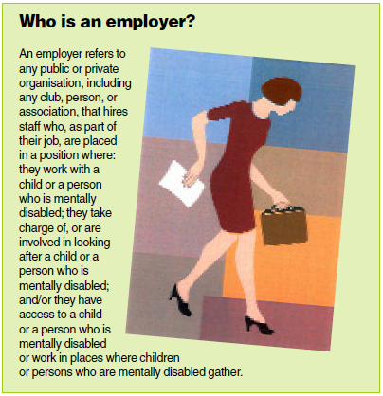Q12. May members of the public, or school governing bodies, enquire whether an individual is in the Register?
- Yes, employers who have employed officials working with children in their cause of employment may establish by way of application to the Registrar whether their employees are in the register as required in terms of the Act.
Q13. What are the obligations of employees?
- An employee (working with children or people who are mentally disabled) in the employ of an employer at the commencement of this Chapter, who is or was convicted of a sexual offence against a child or a person who is mentally disabled, irrespective of whether or not such offence was committed or allegedly committed during the course of his or her employment, must without delay disclose such conviction or finding to his or her employer.
Q14. What are the implications of having one’s details added in the Register?
- The implications of having one’s details included in the Register is that such a person may not be allowed work with children or people who are mentally disabled or have access to them
Q15. Once a person’s details are in the Register, can they be removed?
- Yes, the details contained in the Register can be removed by way of application to the Registrar. However; this will only depend on the type of sentence received upon conviction. Some details may not be removed.
Q16. What must an employer do if a staff member’s name is on the register?
If an employer at any time finds out that the name of an employee appears in the register, the employer must move that employee to another post which will not bring the worker into contact with a child or a person who is mentally disabled. In the event this is not possible, the employer will be required to terminate the employment contract.
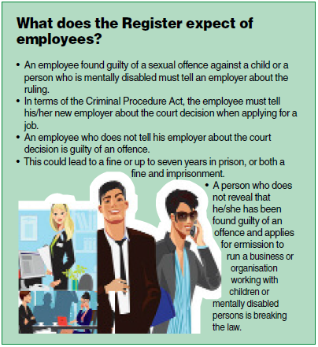Q17. What does the register expect of employees?
Honesty! An employee found guilty of a sexual offence against a child or a person who is mentally disabled must tell an employer about the ruling. In terms of the Criminal Procedure Act, the employee must tell his/her new employer about the court decision when applying for a job. Not telling an employer about a court decision in respect of sexual offence could lead to one getting a fine or imprisonment, or both. A person who does not reveal that he/she has been found guilty of an offence and applies for permission to run a business or organisation working with children or mentally disabled persons is breaking the law.
Questions and Concerns?
We welcome your questions and comments. For more information about the National Register for Sex Offenders, please contact the Department of Justice and Constitutional Development.
Enquiries
NRSO
The Registrar: Ms Ntombizodwa Matjila
Private Bag X81, Pretoria, 0001
Tel: 012 315 1656, Fax: 086 677 5264, E-mail: nrso@justice.gov.za OR
Mr Joseph Mogoshane (SLA, Tel 012 315 1998, Email: JMogoshane@justice.gov.za)

